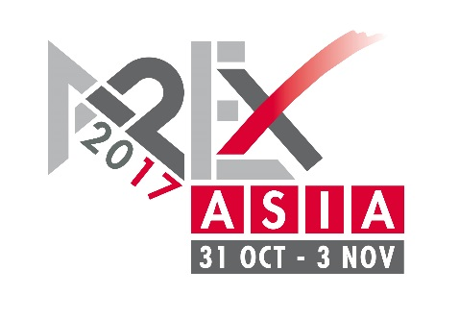
PRESS RELEASE
6 March, 2017

HAULOTTE signs up
for APEX Asia
French aerial platform manufacturer Haulotte, one of the top five AWP suppliers in the world, is the latest company to sign-up for the first APEX Asia exhibition in Shanghai on 31 October to 3 November this year.
Haulotte, which has taken a 168 square metre stand at the show, joins other big name companies attending the show, including JLG Industries, Skyjack, Dingli, Mantall and Sinoboom.
Haulotte has been active in the Chinese and Asian market for many years and was one of the first to establish a manufacturing plant in China, opening its Changzhou facility in 2009.
Exhibitors at APEX Asia now include: Eastman, Dingli, Goman, Haulotte, JLG Industries, Liugong, LGMG, Mantall, Moba, Runshare, Sinoboom, Sivge, Skyclimber Skyjack, TVH, XCMG and Yamai.
The show, which is the sister event to APEX in Europe, will be co-located with CeMAT Asia, the established material handling and logistics exhibition that attracts more than 75,000 visitors. Both events will be held at the Shanghai New International Expo Centre (SNIEC).
APEX Asia, which will be held in Hall N1 at SNIEC, is the first dedicated showcase of access equipment in China and held at a time of rapid growth in the Chinese access market.
“The show has generated enormous interest and we are delighted to have so many suppliers on board at this early stage”, said Tony Kenter, managing director of show organiser Industrial Promotions International B.V. (I.P.I.).
“APEX Asia will bring together Chinese and Asian users and buyers of access equipment at a single show where they can see a wide variety of machines under one roof. Co-locating with CeMAT Asia will also give access equipment exposure to a large audience of industrial equipment professionals, such as owners of forklift trucks.”
Also taking place in Hall N1 will be the International Rental Conference (IRC), which will be held on the first day of the show in a dedicated conference space.
IRC attracts an audience of 300 to 400 rental professionals, and this year’s speaker line-up includes senior figures from United Rentals (USA), Kanamoto (Japan), Zeppelin Rental (Germany), Haulotte (France) and Sycor (Germany).

FOR EDITORS
For information and images, see www.apexasiashow.com, or contact:
Han Heilig
Tel: +31 (0)255 530 577
E-mail: han@practica.nl
For further information, visit:
www.apexasiashow.com
www.khl.com/irc
www.cemat-asia.com
APEX ASIA 2017
APEX Asia will be organised by UK-based publisher KHL Group and Netherlands-based exhibitions company Industrial Promotions International (IPI). Like its European sister show, APEX Asia will cover the entire spectrum of access equipment, including scissor lifts, self-propelled booms, smaller vertical-mast platforms and vehicle mounted platforms. Other equipment and services on show will include fall-protection equipment, access towers, rental software suppliers, and used equipment specialists.
CEMAT ASIA
Deutsche Messe has staged CeMAT ASIA, Asia’s leading trade fair for intralogistics and supply chain management, in Shanghai since 2000. CeMAT ASIA 2015 featured 472 exhibitors and attracted more than 70,000 visitors from 82 countries. CeMAT ASIA belongs to Deutsche Messe’s CeMAT Worldwide portfolio, which includes trade fairs in Australia, Brazil, China, India, Indonesia, Italy, Russia, and Turkey.

