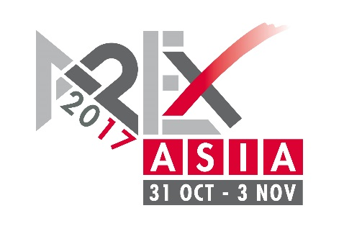
PRESS RELEASE
4 November, 2016
• Asian version of established APEX access equipment show parallel to CeMAT ASIA 2017 in Shanghai
• European APEX will continue at its Amsterdam home; next edition from 2 to 5 May 2017

First APEX Asia to be held in November 2017
Shanghai/Hannover. KHL Group and B.V. Industrial Promotions International (IPI), in cooperation with Deutsche Messe AG, are launching an Asian version of their popular APEX aerial platform exhibition: The premiere of APEX Asia is scheduled for November 2017 at the APEX Asia is an offshoot of the established European APEX, which runs next from 2 to 4 May 2017 at the Amsterdam RAI Convention Centre in the Netherlands.

China and Asia are among the fastest growing aerial platform markets in the world. APEX Asia is the showcase where manufacturers and dealers promote modern access equipment to buyers and users across the entire continent. APEX Asia is co-located with CeMAT ASIA – Asia’s leading trade fair for intralogistics and supply chain management – giving APEX exhibitors access to CeMAT ASIA’s 70,000 visitors. APEX Asia will be located in Hall W5 at CeMAT ASIA with free movement of visitors between the two shows.
“APEX is an established and well-liked show on the access industry calendar, but with the Chinese and Asian market developing fast it is clear that this region would benefit from a local show dedicated to access equipment. Since the first APEX in 1996, the fair has played an important role in promoting the access industry and creating a true access community. APEX Asia brings these same benefits to the Asian market, promoting modern access equipment and developing a mature access industry,” said Tony Kenter, Managing Director of IPI. “Co-locating with CeMAT is an enormous benefit for APEX Asia. We are taking advantage of established links between the material handling and aerial platform sectors in China, where many early adopters of access come from the industrial truck sector. APEX Asia exposes aerial platforms to an enormous audience of current and potential buyers.”
“Since its premiere in 2000, CeMAT ASIA has become Asia’s leading intralogistics trade fair. Together with the co-located events PTC ASIA, Comvac ASIA and Industrial Supply ASIA, we have achieved growth in exhibitor and visitor numbers every year. In 2015, more than 2,200 companies exhibited on an area of 155,500 square meters. With APEX Asia we welcome an event that perfectly fits into our existing portfolio and offers visitors even more attractions,” said Wolfgang Pech, senior vice president at Deutsche Messe AG.
Access International, the KHL Group’s magazine, and the International Powered Access Federation (IPAF), are APEX Asia supporters.
Alongside APEX Asia and CeMAT ASIA, KHL will stage its International Rental Conference (IRC), an annual event for the equipment rental sector which KHL has held in China since 2013. The KHL publication International Rental News (IRN) organizes the conference. IRC attracts audiences of up to 300 people for presentations from such companies as United Rentals, Loxam, Nikken, Coates Hire, Hertz Equipment Rental Co and HSS Hire. Staging the conference alongside APEX Asia and CeMAT ASIA ensures a core audience of Asia’s most important access rental managers and owners.
APEX Asia 2017
APEX Asia will be organised by UK-based publisher KHL Group and Netherlands-based exhibitions company Industrial Promotions International (IPI). Like its European sister show, APEX Asia will cover the entire spectrum of access equipment, including scissor lifts, self-propelled booms, smaller vertical-mast platforms and vehicle mounted platforms. Other equipment and services on show will include fall-protection equipment, access towers, rental software suppliers, and used equipment specialists.

CeMAT ASIA
Deutsche Messe has staged CeMAT ASIA, Asia’s leading trade fair for intralogistics and supply chain management, in Shanghai since 2000. CeMAT ASIA 2015 featured 472 exhibitors and attracted more than 70,000 visitors from 82 countries. CeMAT ASIA belongs to Deutsche Messe’s CeMAT Worldwide portfolio, which includes trade fairs in Australia, Brazil, China, India, Indonesia, Italy, Russia, and Turkey.

Your contact for further information:
Brigitte Mahnken-Brandhorst
Tel.: +49 511 89-3 10 24
E-mail: brigitte.mahnken@messe.de

Further press releases as well as photos are available at:
www.cemat.de/pressservice

